EEG Lab Protocol with VBS Controls
This setup is for VBS with fully blocked
So questions about the protocol?
- How do we do the equipment check?
- How do we measure the impedances of the electrodes?
- How do we test TTL synchronisation
- We should build the support for the finger
- For the moment there's no real code or protocol for the computer analysis check or for the control of EM interference
- There should be an easy way to remove the nipple

I. Experimental Setup - Step by Step
Before Starting - Equipment Check
- EEG System Setup (30 minutes)
  - Shut down all electronic devices
  - Turn on research-grade EEG machine
  - Apply 32 electrode cap on subject's head (based on APEEGE)
    - Measure the distance from the nasion to occipital bone.
    - Search the middle point where Cz should be
    - Measure the distance for Fz on 30%
    - Measure the distance for Pz on 70%
    - Measure the distances between the preauricular point (just before the ear tubes)
    - Search the middle point where Cz should be
    - Control if C3 and C4 are on the 30 and 50 %
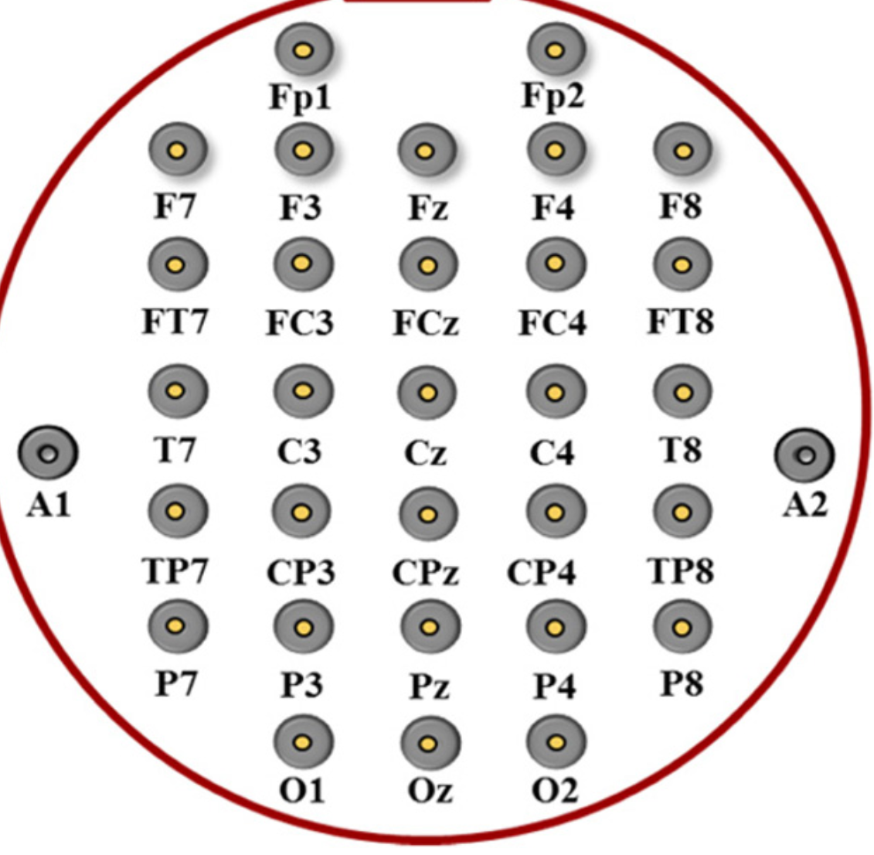
https://www.youtube.com/watch?v=oK26b0YrkXE
  - Check the channel mapping if everything is right in the yama file:
CAP | FREEEEG32
site | CH
T7 | CH01
C3 | CH02
T8 | CH05
FC4 | CH06
FC3 | CH09
C4 | CH10
CP3 | CH13
CP4 | CH14
REF (CZ|CPZ) | REFERENCE
GND (FPZ|FZ) | VCM/Bias
- Apply gel and pressure to the electrodes. Check if all electrode impedances are below 10 kΩ (ideal: below 5 kΩ)

- Vibrotactile Stimulator (VBS) Setup
  - Connect vibrotactile device to controller
  - Test TTL trigger synchronization with EEG
  - Vibration level on 10
  - Prepare both contact and non-contact positions
- Environment Preparation
  - Use sound-attenuated room or booth (researchers should make no interfering movement or noise)
  - Dim lighting for subject comfort
  - Ensure subject is seated comfortably
  - Close all the windows and doors
II. Experimental Procedure
Phase 1: Control (10 minutes)
Purpose: Check if the device itself causes EEG changes without touching the finger
Step 1: Device OFF Baseline (1 minute)
- Tell subject: "Please sit quietly with eyes open"
- Record EEG with VBS device completely OFF
Step 2: Device ON but NOT Touching (1 minute)
- Tell subject: "Please put your finger on the support device "
- Finger is resting on the support device
- Device is vibrating in air near the finger at 40 Hz
Step 3: Analysis Check (1 minute)
- Computer automatically compares:
  - EEG power when device OFF vs ON (no contact)
  - Looks for electromagnetic or audio contamination
- If significant contamination detected, you'll see a warning message
- Decision: Continue or troubleshoot based on results

Phase 2: Normal Resting Baseline (5 minutes)
Purpose: Record normal EEG with nipple actually touching the finger
Step 4: Device ON with Contact
- Tell subject: "Please put your finger on the nipple "
- Record 1-minute eyes open
- This is your "normal operation" baseline

Phase 3: Nautral frequency stimulation (25 minutes per frequency)
Purpose: Neurostimulation with 40 Hz,80 Hz, 160 Hz, 320 Hz
Step 5: Neurostimulation with blocked protocol (20 minutes)
Subject just sits relaxed, no special task. Patients should remain contact so we use clamps on the triggers.

- FOT (finger on the tractor ) (8m20s)
- Tell subject: "Please put your finger on the nipple "
- You set the vibration frequency to 40 Hz.
- You set the number of cycles to 50 and the duration of a cycle is 10s. (8m20)

2. IFNFN (Finger In Noise Field, Not Feeling Nipple) (8m20)
- We remove the nipple
- Tell subject: "Please put your finger on the case "
- You set the number of cycles to 50 and the duration of a cycle is 10s. (8m20)

Step 6: Quick Control Check (5 minutes)
- Briefly repeat the "device ON, no contact" test (30 seconds)
- Ensure no contamination has developed during testing

III. What the Computer is Checking For You
Contamination Detection
The system automatically monitors for:
- Electromagnetic Interference
  - Does EEG power increase when device is just near the finger?
  - Are there new frequency peaks when device is ON?
  - Is there increased line noise (50/60 Hz)?
- Audio Contamination
  - Can the brain "hear" the vibrations through air?
  - Are there EEG patterns that match device sounds?
- Vibration Transmission
  - Are vibrations traveling through the chair or table?
  - Is there mechanical coupling to EEG equipment?
Quality Metrics
Good Data:
- Signal-to-noise ratio > 3 dB
- Phase locking > 0.2
- No significant contamination
- Consistent results across trials
Questionable Data:
- Some contamination detected but below threshold
- Moderate signal quality
- May need interpretation caution
Poor Data:
- Significant contamination
- Low signal quality
- Should be re-run or excluded

IV. Troubleshooting - Common Issues
If Contamination is Detected:
- Check grounding - Ensure proper equipment grounding
- Increase distance - Move VBS further from EEG equipment
- Add shielding - Use additional electromagnetic shielding
- Use white noise - Mask potential audio contamination
If Signal Quality is Poor:
- Check electrodes - Re-check impedances
- Reduce movement - Ensure subject is still
- Adjust intensity - Increase vibration amplitude slightly
- Check connections - Verify all cables are secure

V. Output Files and Results
What Gets Saved:
- Raw EEG data - All recordings in standard format
- Control condition reports - Device OFF vs ON comparisons
- Neurostimulation response - Response at each tested frequency

VI. Timeline Summary
Total Time: 45-65 minutes
- Setup: 30 minutes
- Control conditions: 10 minutes
- Resting baseline: 5 minutes
- Neurostimulation: 25 minutes
- Analysis: 5 minutes

